**Project Report**

**Online Grocery Store**

**::**

**Submitted by**

**Baisakhi Bhattacharya**

Contents

Introduction 3

Introduction 3

Project Objective 3

Project Scope 3

Project Analysis 3

Software Specifications 3

Hardware Specifications 3

Project Instructions 4

Assumptions 4

Feasibility Study 4

Testing Output 4

# Introduction

## Introduction

Online shopping is the process whereby consumers directly buy goods, services etc. from a seller interactively in real-time without an intermediary service over the internet. Online shopping is the process of buying goods and services from merchants who sell on the Internet. Since the emergence of the World Wide Web, merchants have sought to sell their products to people who surf the Internet. Shoppers can visit web stores from the comfort of their homes and shop as they sit in front of the computer. Consumers buy a variety of items from online stores. In this project, we have worked on an online grocery store, which sells pre-packaged products.

## Project Objective

* To purchase products in bulk instead of buying a single item
* If the customer requires 14 sliced ham, he must order 2 numbers of 5 package and 2 numbers of 3 package

## Project Scope

This product has great future scope. Online shopping Internet software developed on and for the Windows and later versions environments and Linux OS.

# Project Analysis

## Software Specifications

* Operating system :- Windows XP SP-3 / 7/8
* Web Browser:- Internet Explorer 6.0/7.0,Google Chrome, Mozilla Firefox
* Program Code:-C#

## Hardware Specifications

* Minimum 512MB Main Memory.
* CPU speed: 2.6GHz.
* Monitor: EGA / SVGA (display), 800X600 24 bits True Colour.
* Standard Keyboard: 106 Keys with Separate Function Keys & Numeric Pad.
* Mouse: PS /2 Optical mouse.
* CD-RO : Required

## Project Instructions

* Based on the given requirements, the store sells 3 products: sliced ham, yoghurt and toilet rolls.
* There are 2 packages available for sliced ham – package 3 and package 5. The prices are $2.99 and $4.99 respectively.
* There are 3 packages available for yoghurt – package 4, package 10 and package 15. The prices are $4.95, $9.95, $13.95 respectively.
* There are 3 packages available for toilet rolls – package 3, package 5 and package 9. The prices are $2.95, $4.95, $7.99.
* Each order should contain the minimal number of packs.

## Assumptions

We have assumed that each item has its own product id and the customer needs to enter that id to choose a product. For example, the product id of sliced ham is 1, so the customer needs to type 1 to choose sliced ham.

# Feasibility Study

The product is economically feasible. It reduces the processing time and workload. This product is operationally feasible as it is designed specifically for E-Governance. The system is self-explanting and does not need any entire sophisticated training, hence it is technically feasible too.

# Testing Output

Main menu display:

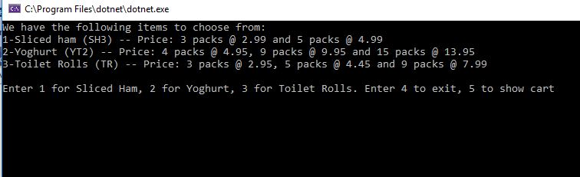

For sliced ham:

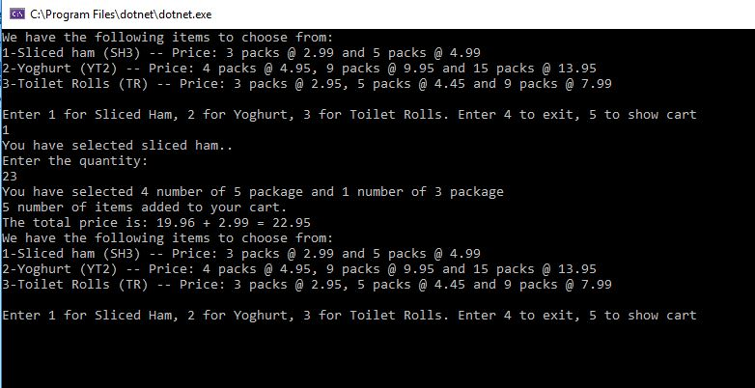

For yoghurt:

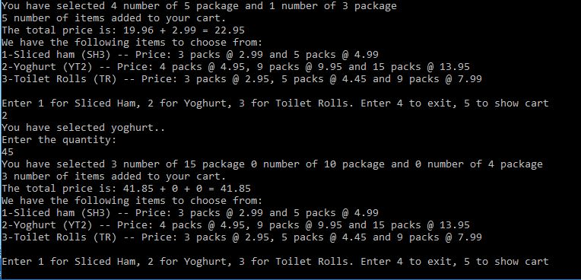

For toilet rolls:

